Deep Learning

**Introduction:**

Deep learning is a method in artificial intelligence (AI) that teaches computers to process data in a way that is inspired by the human brain. Deep learning models can recognize complex patterns in pictures, text, sounds, and other data to produce accurate insights and predictions. You can use deep learning methods to automate tasks that typically require human intelligence, such as describing images or transcribing a sound file into text.   
In deep learning, artificial neural networks are made up of numerous layers of interconnected nodes known as artificial neurons or units. These networks are named "deep" because there are numerous hidden layers between the input and output levels. Each layer is made up of neurons that perform computations on input data before passing the results on to the next layer.

Deep learning has achieved remarkable success in various domains, including computer vision, natural language processing, speech recognition, and reinforcement learning. It has significantly improved the state-of-the-art performance in tasks such as image classification, object detection, speech synthesis, machine translation, and many others.

**Why is deep learning important?**

1. Improved performance: Deep learning has demonstrated state-of-the-art performance in various complex tasks, surpassing traditional machine learning methods. It can learn hierarchical representations from raw data, enabling more accurate predictions and decision-making.
2. Automatic feature learning: Deep learning models can automatically learn relevant features from raw data, eliminating the need for manual feature engineering. This significantly reduces the human effort required to design and extract features, making the process more efficient and effective.
3. Handling large-scale data: Deep learning excels in handling large-scale datasets. It can effectively process and learn from massive amounts of labeled data, enabling better generalization and more robust models.
4. Real-world applications: Deep learning has enabled groundbreaking applications in areas such as autonomous driving, healthcare, finance, security, and entertainment. It has revolutionized image and speech recognition, language translation, medical diagnosis, fraud detection, and many other tasks, leading to significant societal and economic impact.

**What are the uses of deep learning?**

Deep learning has a wide range of applications across various domains. Here are some common uses of deep learning:

1. Computer Vision: [Computer vision](https://aws.amazon.com/computer-vision/) is the computer's ability to extract information and insights from images and videos. Computers can use deep learning techniques to comprehend images in the same way that humans do. Computer vision has several applications, such as the following:

* Content moderation to automatically remove unsafe or inappropriate content from image and video archives
* Facial recognition to identify faces and recognize attributes like open eyes, glasses, and facial hair
* Image classification to identify brand logos, clothing, safety gear, and other image details.

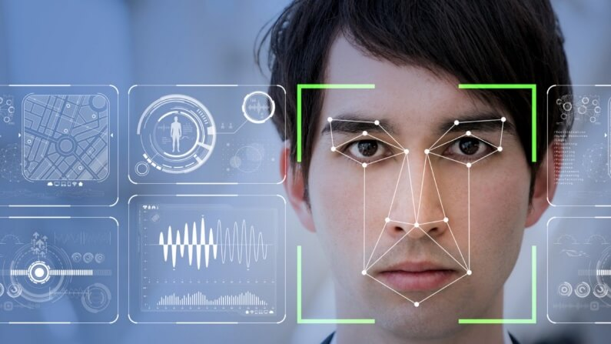

1. Natural language processing: Computers use deep learning algorithms to gather insights and [meaning from text data](https://aws.amazon.com/comprehend/) and documents. This ability to process natural, human-created text has several use cases, including in these functions:

* Automated virtual agents and chatbots
* Automatic summarization of documents or news articles
* Business intelligence analysis of long-form documents, such as emails and forms
* Indexing of key phrases that indicate sentiment, such as positive and negative comments on social media

1. Speech recognition: Deep learning models can analyze human speech despite varying speech patterns, pitch, tone, language, and accent. Virtual assistants such as Amazon Alexa and [automatic transcription software](https://aws.amazon.com/what-is/speech-to-text/) use speech recognition to do the following tasks:

* Assist call center agents and automatically classify calls.
* Convert clinical conversations into documentation in real time.
* Accurately subtitle videos and meeting recordings for a wider content reach.

**How deep learning works**

Deep learning neural networks, or artificial neural networks, attempts to mimic the human brain through a combination of data inputs, weights, and bias. These elements work together to accurately recognize, classify, and describe objects within the data.

Deep neural networks consist of multiple layers of interconnected nodes, each building upon the previous layer to refine and optimize the prediction or categorization. This progression of computations through the network is called forward propagation. The input and output layers of a deep neural network are called *visible*layers. The input layer is where the deep learning model ingests the data for processing, and the output layer is where the final prediction or classification is made.

**Deep learning vs. machine learning**

If deep learning is a subset of machine learning, how do they differ? Deep learning distinguishes itself from classical machine learning by the type of data that it works with and the methods in which it learns.

Machine learning algorithms leverage structured, labeled data to make predictions—meaning that specific features are defined from the input data for the model and organized into tables. This doesn’t necessarily mean that it doesn’t use unstructured data; it just means that if it does, it generally goes through some pre-processing to organize it into a structured format.

Deep learning eliminates some of data pre-processing that is typically involved with machine learning. These algorithms can ingest and process unstructured data, like text and images, and it automates feature extraction, removing some of the dependency on human experts. For example, let’s say that we had a set of photos of different pets, and we wanted to categorize by “cat”, “dog”, “hamster”, et cetera. Deep learning algorithms can determine which features (e.g. ears) are most important to distinguish each animal from another. In machine learning, this hierarchy of features is established manually by a human expert.

**Example:** Below is a simple demonstration of building a deep learning model in Python for predicting handwritten digits using the popular MNIST dataset. We'll use TensorFlow and Keras for this example.

The main objective of this code is to build a simple neural network model for handwritten digit recognition using the MNIST dataset.

# Import the required libraries

import tensorflow as tf

from tensorflow.keras import layers, models

from tensorflow.keras.datasets import mnist

import matplotlib.pyplot as plt

# Load the dataset

(train_images, train_labels), (test_images, test_labels) = mnist.load_data()

# Check the total number of training and testing samples

print(f"Number of training samples: {len(train_images)}")

print(f"Number of testing samples: {len(test_images)}")

# Visualize the data

plt.figure(figsize=(10, 5))

for i in range(10):

    plt.subplot(2, 5, i + 1)

    plt.imshow(train_images[i], cmap='green')

    plt.title(f"Label: {train_labels[i]}")

    plt.axis('off')

plt.show()

# Build the model

model = models.Sequential()

model.add(layers.Flatten(input_shape=(28, 28)))  # Flatten the 28x28 images into a 1D array

model.add(layers.Dense(128, activation='relu'))

model.add(layers.Dense(10, activation='softmax'))  # 10 classes for digits 0-9

# Loss and Optimization

model.compile(optimizer='adam',

              loss='sparse_categorical_crossentropy',

              metrics=['accuracy'])

# Train the model

model.fit(train_images, train_labels, epochs=5, validation_data=(test_images, test_labels))

# Test the model and find the accuracy

test_loss, test_accuracy = model.evaluate(test_images, test_labels)

print(f"\nTest Accuracy: {test_accuracy * 100:.2f}%")

Name: Abdihamid Abdirizak Mohamoud Bile

ID: 2022966

Class: 4C

Assignment One: Intro to Deep Learning